Natural wood Siding & Soffit
Timeless Warmth, Lasting Impact
Bring warmth, character, and timeless elegance to your exterior with premium natural wood siding and soffit systems.
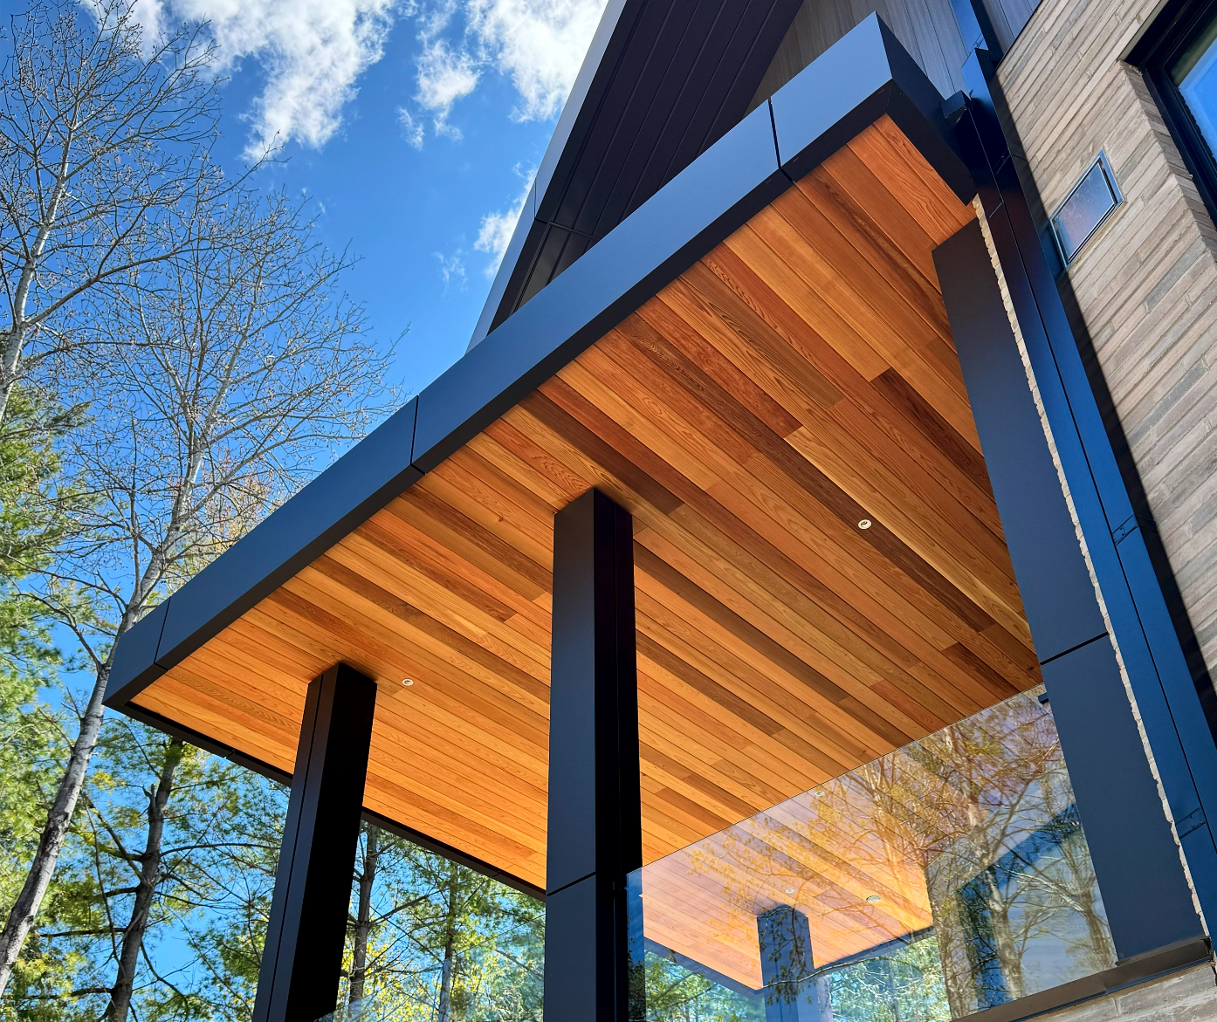
Industrial / Residential / Commercial / Agricultural
At CladCan, we bring you the unmatched character of real wood through a premium collection of siding and soffit products designed to elevate any exterior. Our line includes carefully selected natural cedar, various genuine wood species, engineered wood siding options, and distinctive styles such as board and batten and tongue-and-groove.
From the rustic charm of Eastern white cedar to the dramatic elegance of charred wood finishes, each product is built for lasting performance and visual appeal. Kiln-dried and precision-milled for stability, our wood sidings are available raw, factory-stained, or custom-finished to match your design vision.
Prefer low-maintenance solutions? Our engineered options deliver the rich look of wood with enhanced durability and weather resistance—ideal for modern builds and high-performance exteriors.
Whether you’re after natural beauty, bold texture, or a maintenance-friendly alternative, our wood siding and soffit collection offers timeless design with lasting value.

ENGINEERED WOOD SIDING & SOFFIT

Authentic Woodgrain Look, Without Repetition
Engineered wood siding combines the authentic look of natural wood with advanced manufacturing technology to deliver superior stability, durability, and long-term performance.
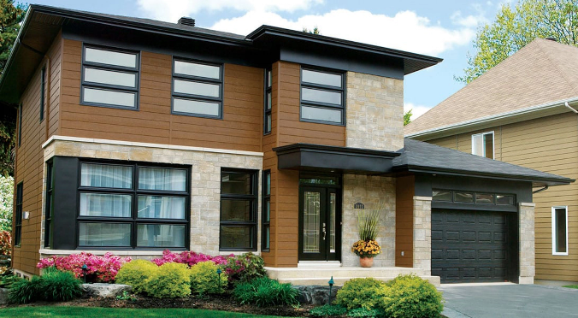
Continuing to redefine what engineered siding can be. With its stunning finish, genuine woodgrain texture, and unmatched durability, no other siding delivers the same combination of beauty and performance...... (Learn More / Expand)

ENGINEERED WOOD SIDING & SOFFIT (EXPANDED)
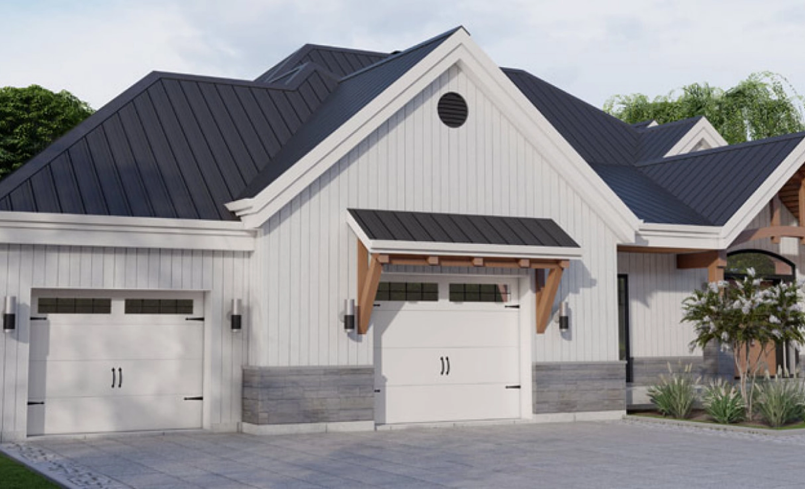
Expanded … Authentic Woodgrain Look — Without Repetition
Continuing to redefine what engineered siding can be. With its stunning finish, genuine woodgrain texture, and unmatched durability, no other siding delivers the same combination of beauty and performance. Once you experience the product, you’ll understand why it’s the top choice for discerning homeowners.
Don’t settle for imitators. CladCan’s Engineered wood is the only high-density fibre (HDF) engineered siding of its kind—built to deliver exceptional performance in even the harshest climates. Each board undergoes extensive testing for resistance to UV exposure, moisture, freezing temperatures, and extreme heat. This rigorous process ensures long-term structural integrity and a flawless finish that stands the test of time.
Striking Finish with Industrial-Grade Protection
Every board is coated with exclusive premium thermoset paint, applied in multiple layers and cured at high temperatures to create a finish that’s not only beautiful but built to last. This advanced process ensures exceptional resistance to fading, cracking, peeling, and splitting, even in the harshest environments.

From coast to coast, through rain, snow, wind, and sun—Maibec CanExel is engineered to endure. With its combination of strength, beauty, and reliability, it’s not just siding—it’s peace of mind for decades to come.

Confidence Backed by Decades of Experience
Our commitment to quality is more than a promise—it’s a guarantee. With over 40 years of proven performance, offers industry-leading warranties that provide lasting peace of mind.
• 25-year limited warranty against buckling, peeling, separating, and chipping
• 15-year limited warranty on the factory-applied finish
• 5-year full warranty covering labour and material replacement at 100%
Built on trust, transparency, and craftsmanship—our warranty coverage ensures your investment is protected for years to come.

Profile Options:

VStyle
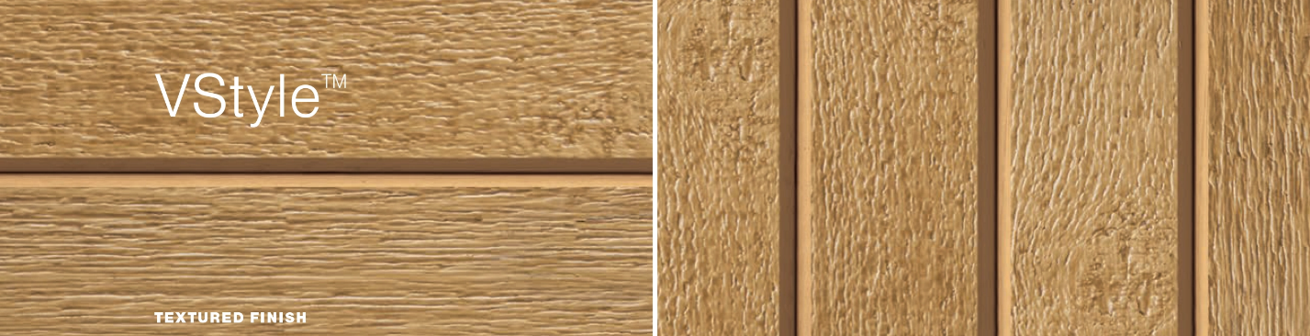
Sleek. Versatile. On-Trend
Designed for today’s architecture, this modern and stylish profile brings a fresh, contemporary edge to any exterior. With its clean lines and adaptable layout, it’s the perfect match for both urban and transitional design styles.

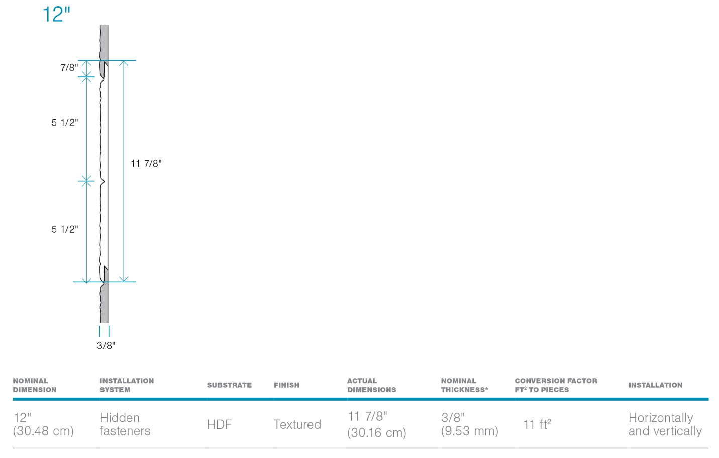

Key Features:
- Compatible with both vertical and horizontal installations, giving you more design flexibility
- Innovative installation system allows for quick, easy, and secure application
- Each 12 ft. board covers 11 sq. ft., maximizing efficiency and minimizing waste
- Available in a curated palette of 18 modern colours

Product Dimensions:
- Length: 12 ft. (3.66 m)
- Nominal Width: 12 in. (30.48 cm)
- Nominal Thickness: 3/8 in. (0.95 cm)

Whether you’re reimagining a single wall or an entire façade, this profile delivers modern appeal, streamlined performance, and effortless installation in one smart package.

Ridgewood D-5
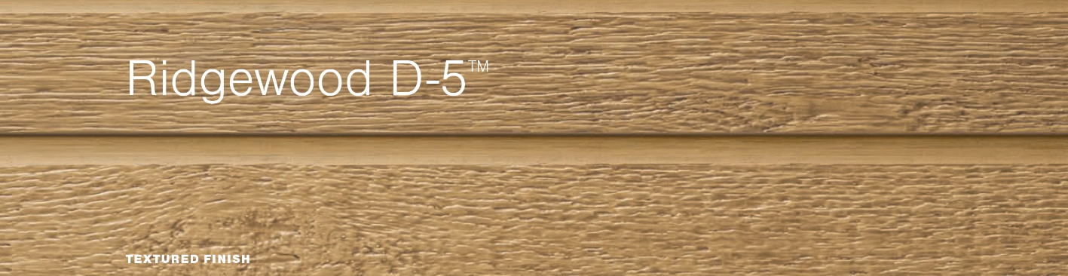
Traditional Charm with a Modern Edge
Bring timeless style to your exterior with Maibec CanExel’s take on the classic Dutch lap profile, enhanced by our signature authentic wood grain finish. This design offers a traditional look with clean lines and subtle shadowing that add depth and dimension to any façade.

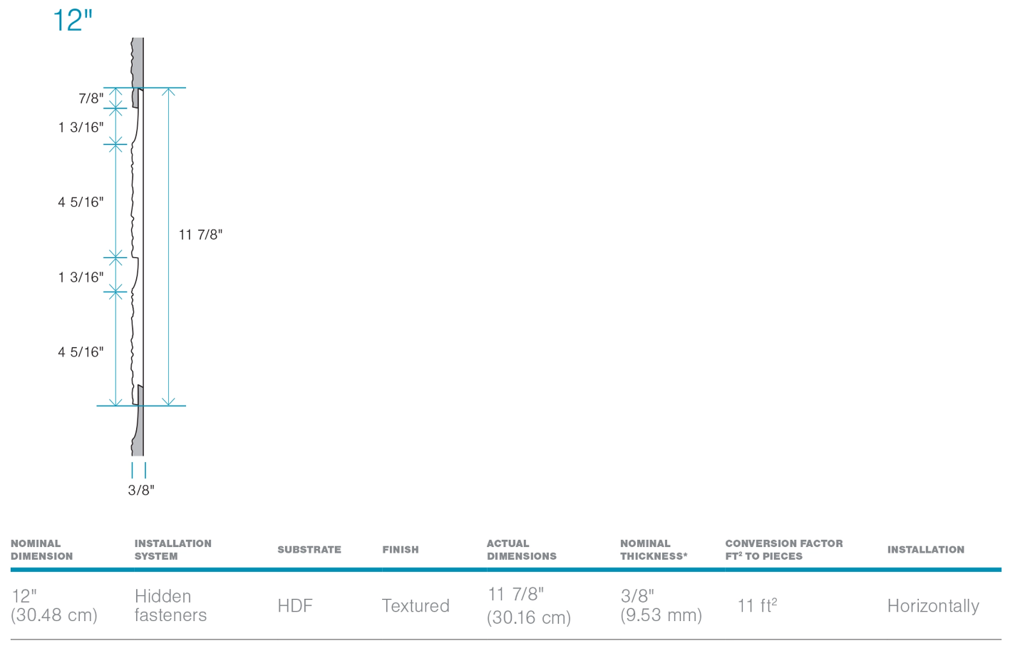

Key Features:
- Classic Dutch lap design for a timeless aesthetic with crisp horizontal shadow lines
- Double-profile configuration gives the appearance of two 5-inch boards in a single panel for faster installation and visual consistency
- Horizontal installation only perfect for colonial, farmhouse, or traditional home styles
- Equipped with a state-of-the-art installation system for speed, accuracy, and a secure fit
- Each 12-foot board covers 11 square feet, helping reduce waste and improve installation efficiency
- Offered in a wide range of 20 rich, fade-resistant colours

Product Dimensions:
- Length: 12 ft. (3.66 m)
- Nominal Width: 12 in. (30.48 cm)
- Nominal Thickness: 3/8 in. (0.95 cm)

Get the best of both worlds: the classic charm of traditional siding and the engineered confidence to last for decades.

Ced’R-Vue 9”
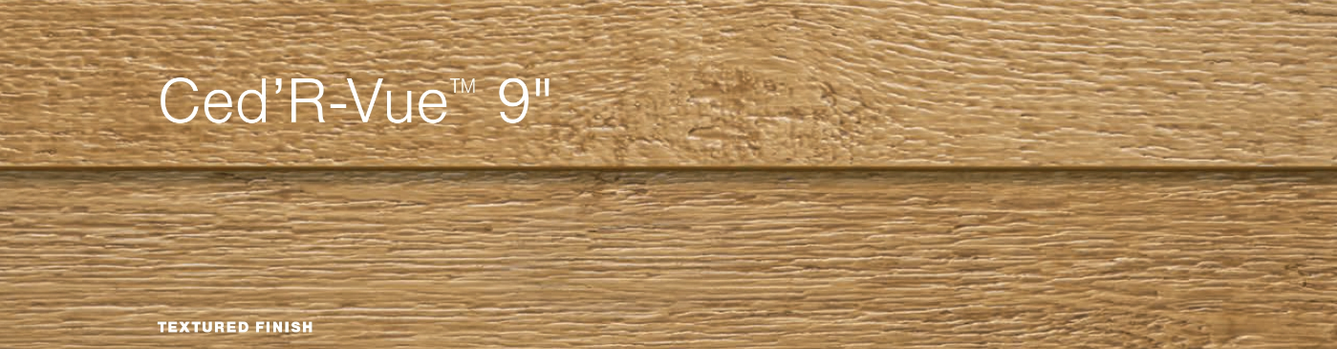
9-Inch Lap Siding — Signature Style with Seamless Simplicity
This profile showcases the signature wood grain texture that defines Maibec CanExel®, combined with a sleek 9-inch lap for a bold, refined appearance. It’s the ideal solution for homeowners and designers seeking a clean, horizontal aesthetic with the trusted performance of engineered siding.

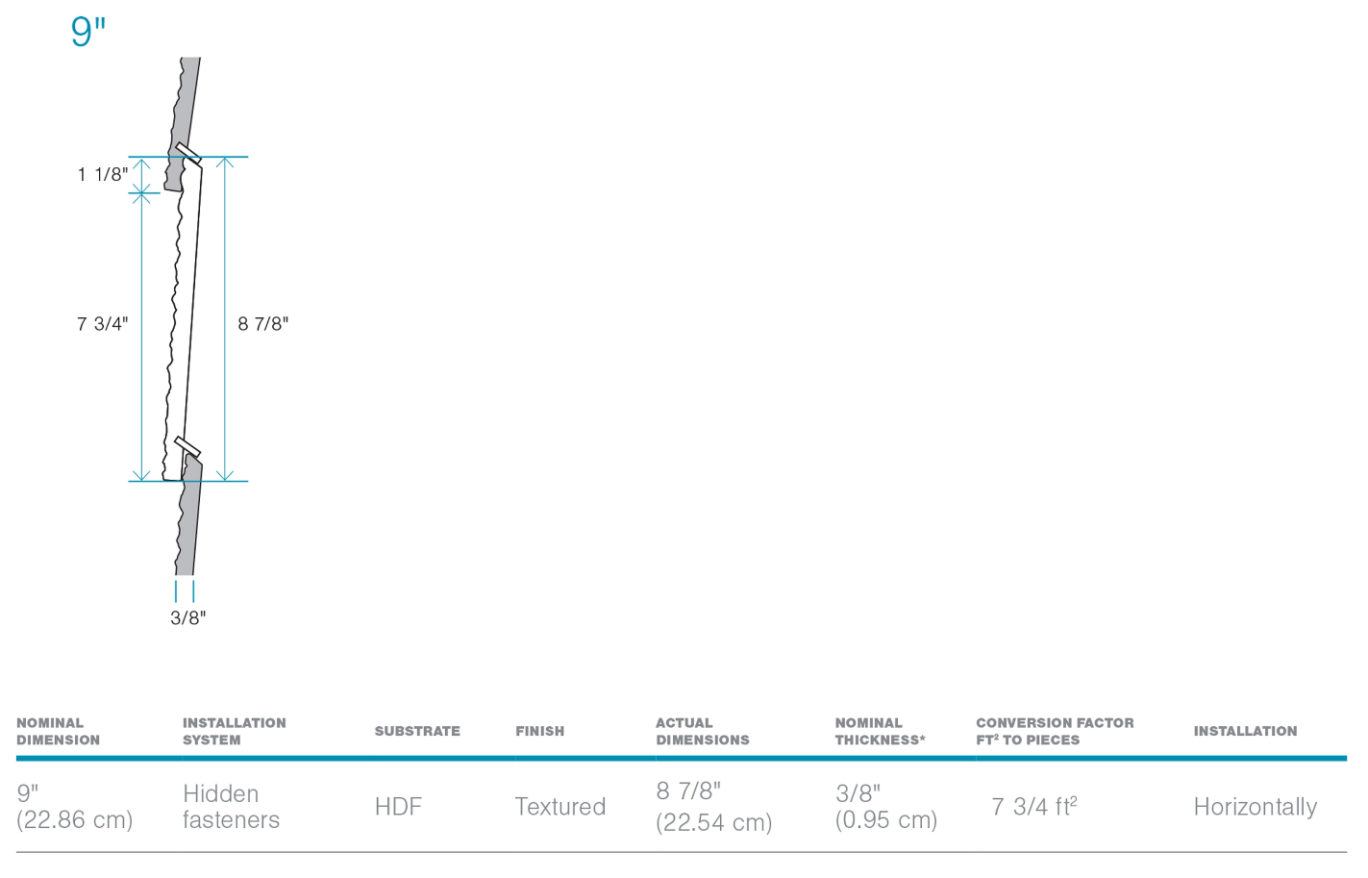

Key Features:
- Features CladCan’s exclusive authentic wood grain finish for a rich, natural look
- 9-inch lap siding profile delivers bold visual lines and a modern, streamlined presence
- Designed for horizontal installation only, ideal for classic or contemporary exteriors
- Built-in state-of-the-art installation system allows for quick, efficient, and secure application
- Each 12-foot board covers 7.75 sq. ft., ensuring excellent material use with minimal waste
- Available in a palette of 20 timeless and trend-forward colours
Product Dimensions:
- Length: 12 ft. (3.66 m)
- Nominal Width: 9 in. (22.86 cm)
- Nominal Thickness: 3/8 in. (0.95 cm)

Whether enhancing a single accent wall or cladding an entire home, this lap siding profile delivers striking visual impact and long-term resilience with the distinctive look.

UltraPlank
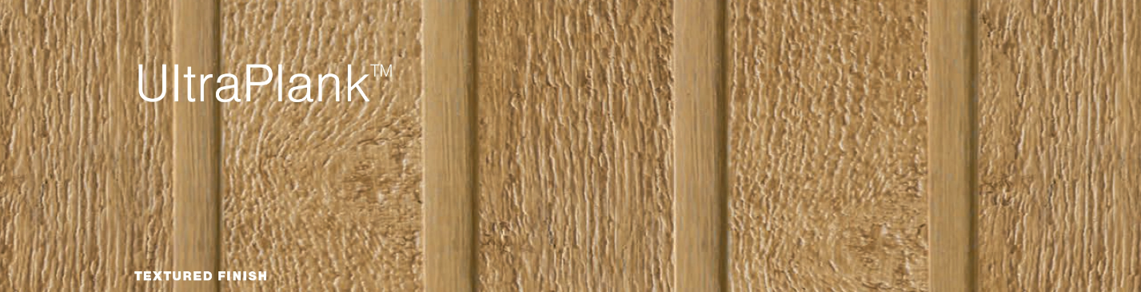
Reverse Board & Batten — Distinctive Design, Flexible Installation
Stand out with the bold architectural style of Reverse Board & Batten profile, a striking design paired with our authentic wood grain texture for a look that’s both rustic and modern. Whether installed vertically or diagonally, this profile adds dimension and movement to any façade.

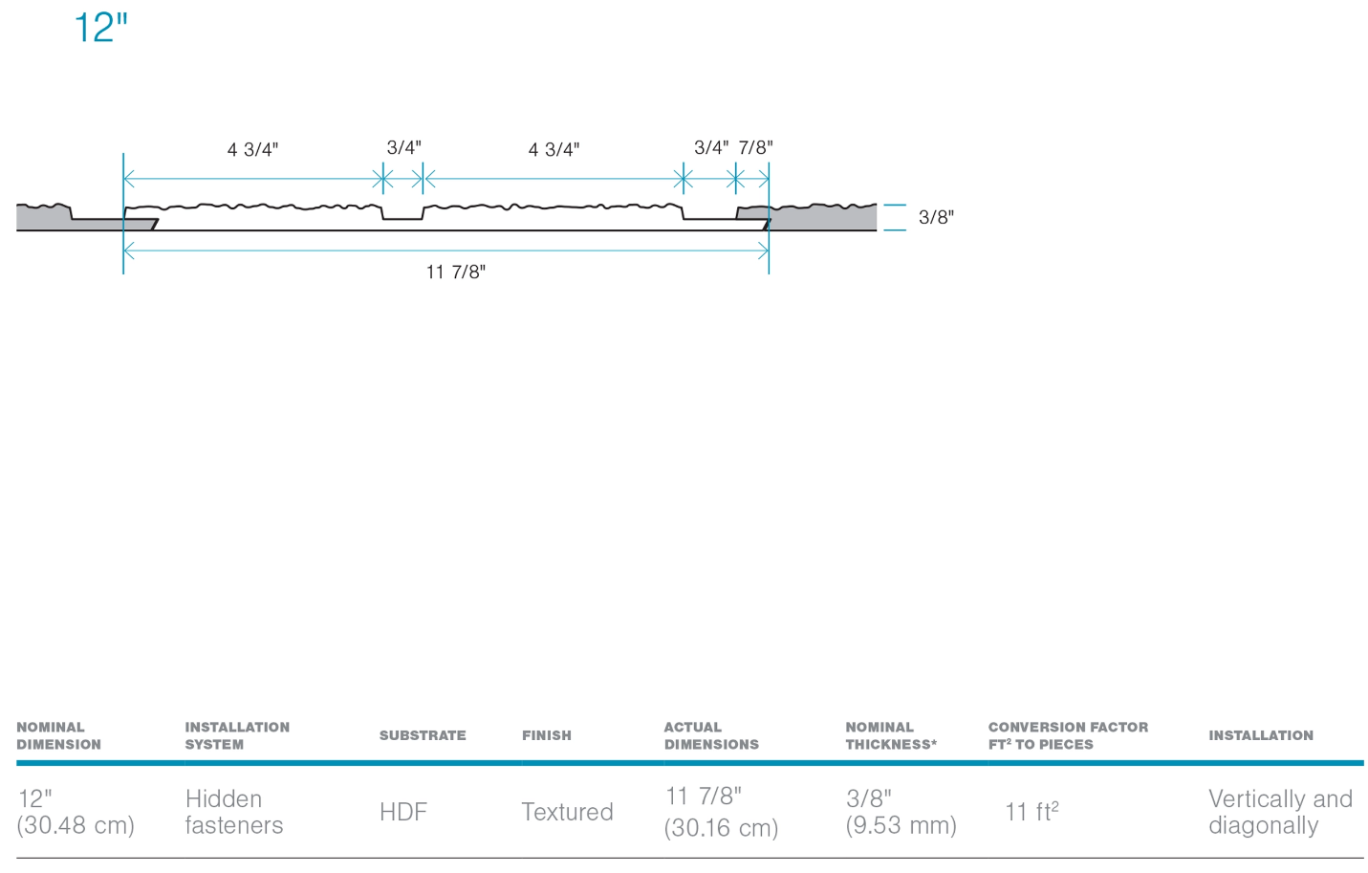

Key Features:
- Unique reverse board & batten profile offers a fresh take on traditional vertical siding
- Compatible with vertical and diagonal installations, giving designers more creative flexibility
- Features an advanced installation system for smooth, accurate, and efficient application
- Each 12-foot board covers 11 square feet, maximizing coverage and minimizing waste
- Available in a curated range of colours (availability may vary)
Product Dimensions:
- Length: 12 ft. (3.66 m)
- Nominal Width: 12 in. (30.48 cm)
- Nominal Thickness: 3/8 in. (0.95 cm)

Perfect for feature walls, gables, and bold architectural accents, the Reverse Board & Batten profile delivers dynamic curb appeal and reliable performance in one distinctive package.

Bring Your Vision to Life
Explore our wide range of siding colours and finishes to turn your ideas into reality. Whether you’re building new or refreshing your exterior, the perfect shade is just a step away from your dream home.

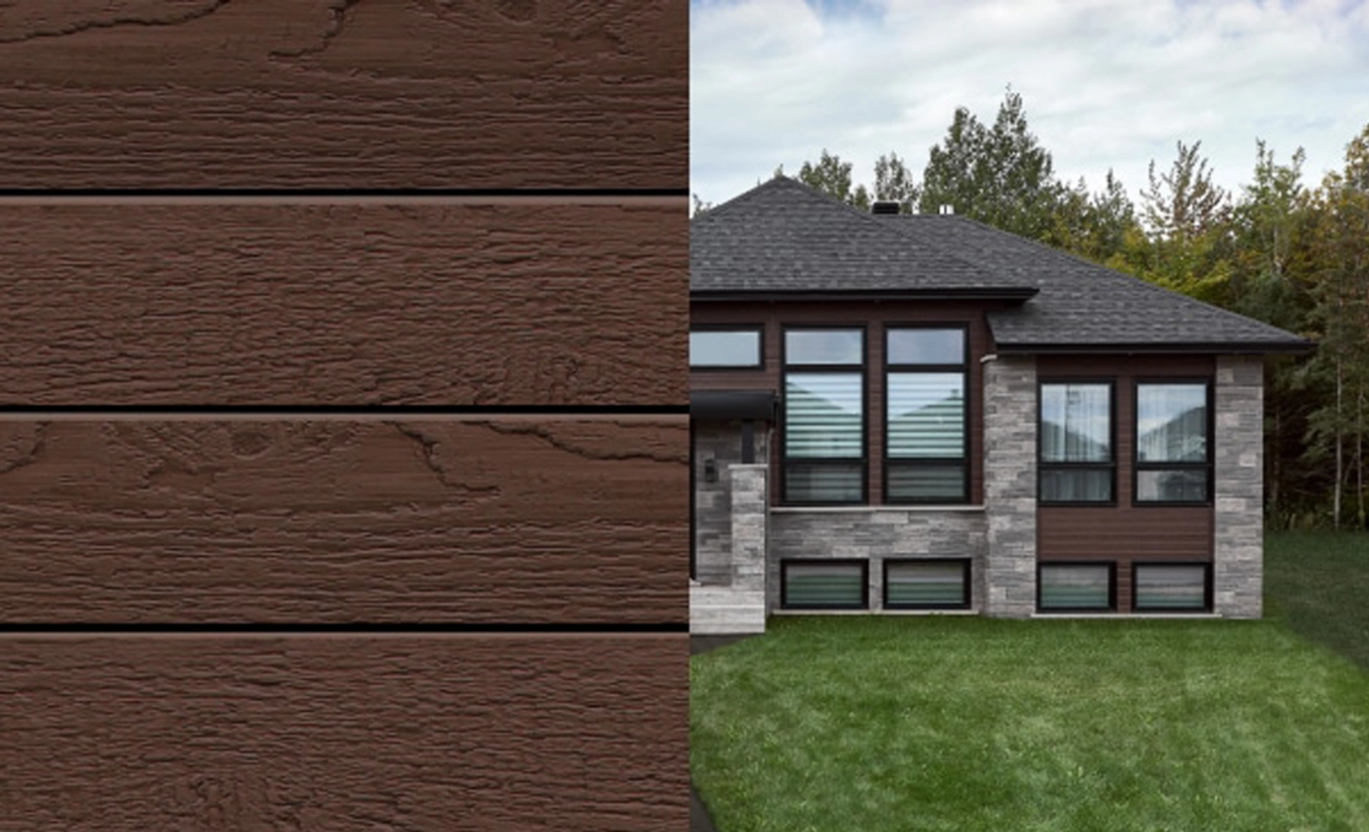

Two-Tone Colours
Subtle variation. Striking impact.
Our two-tone finishes blend complementary hues to highlight wood grain and texture—creating a rich, dimensional look that sets your project apart.
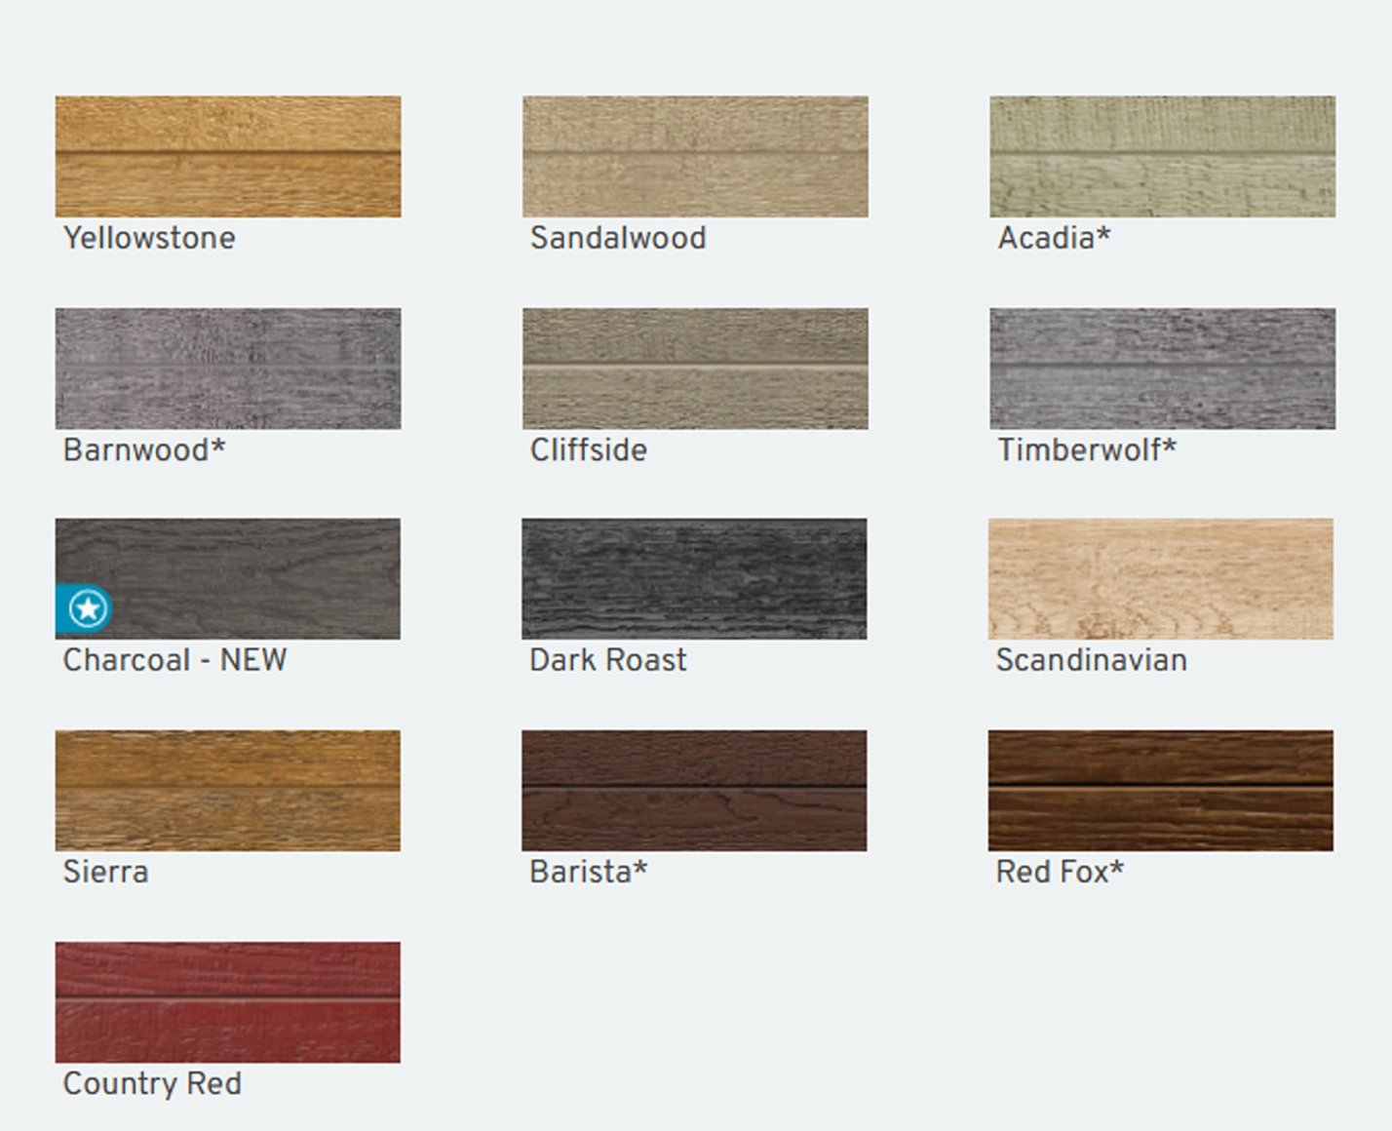
Available colours apply to the Ced’R-Vue™ 6” Snap Lap profile. Availability may vary, please check for specific options.

Solid Colours
A curated selection of rich, solid colours—professionally developed and inspired by nature’s palette. Each tone is designed to complement a variety of architectural styles, adding timeless beauty and bold character to your exterior.

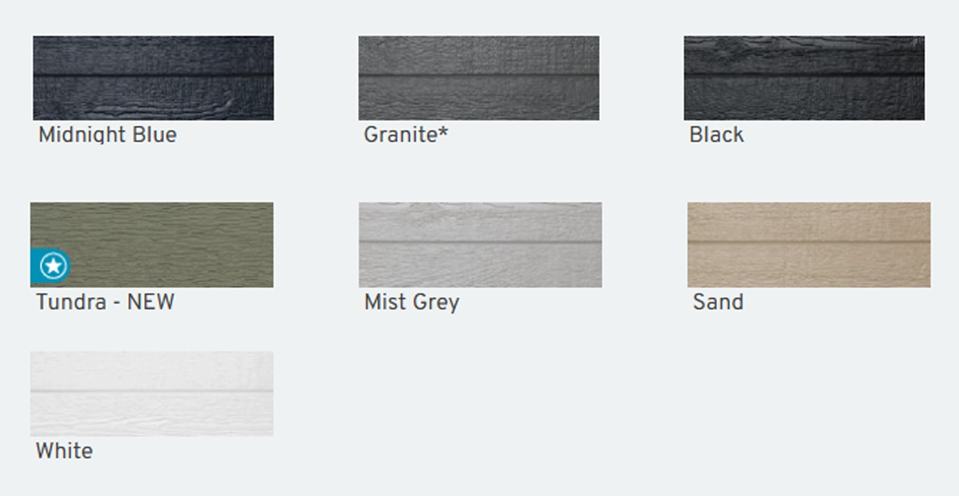
Available colours apply to the Ced’R-Vue™ 6” Snap Lap profile. Availability may vary, please check for specific options.

Personalized Colours, Perfectly Matched
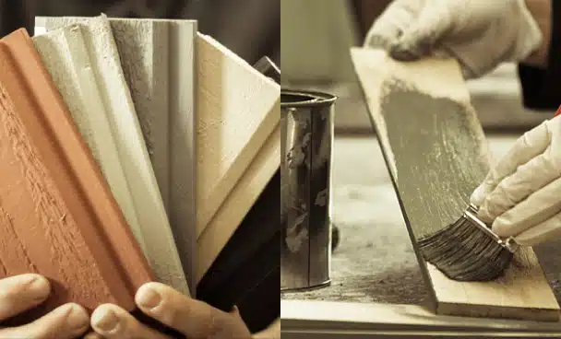
Have a specific colour in mind? With our proven TrueMatch® system, we’ll create a precise solid stain match to bring your vision to life. No matter the shade you choose, every board is coated with our premium-quality stain—factory-applied on all six sides for lasting beauty and protection.

